Title - Intelligent Cognitive Alarm Platform

AI & Analytics Module Documentation
Prepared By: Indhu Ravula

1. Project Description
The Intelligent Cognitive Alarm Platform is an AI-assisted smart alarm system designed to improve users' waking habits and daily routines. Unlike traditional alarms, the system tracks user behavior by calculating a Habit Score based on on-time wake-ups, challenge completion, and snooze usage.
The AI & Analytics module provides habit analysis, predicts the user's difficulty level, generates personalized recommendations, and monitors daily and weekly progress through FastAPI APIs. The system encourages users to develop healthy habits using intelligent analytics and rule-based decision making.

2. Environment Setup
The AI & Analytics module was developed locally using Python and FastAPI. Visual Studio Code was used as the primary development environment, and all APIs were tested using Swagger UI.
Hardware
- Windows 11
- Intel Core i5 Processor
- 8 GB RAM

Software
- Python 3.12
- Visual Studio Code
- FastAPI
- Uvicorn

Python Libraries
- FastAPI
- Uvicorn
- NumPy
- Pandas (Future)
- Scikit-learn (Future)

Code Explanation
- analytics.py — calculates the Habit Score using the weighted formula based on on-time wake-up percentage, challenge completion rate, and snooze performance.
- main.py — creates the FastAPI application, defines all API endpoints, and connects the analytics, difficulty, recommendation, and progress modules.
- difficulty.py — predicts the difficulty level (Easy, Medium, or Hard) based on the calculated Habit Score.
- recommendation.py — generates personalized recommendations for users according to their Habit Score and wake-up performance.
- progress.py — tracks and returns the user's daily progress, weekly progress, current Habit Score, and difficulty level through the Progress API.
4. IMPLEMENTATION AND RESULTS
Figure 4.1: Project Folder Structure
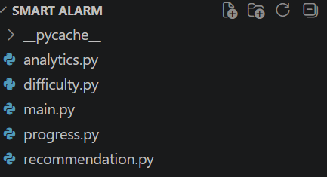
Description: Shows the modular folder structure of the Smart Alarm AI & Analytics project.

Figure 4.2: FastAPI Swagger Interface
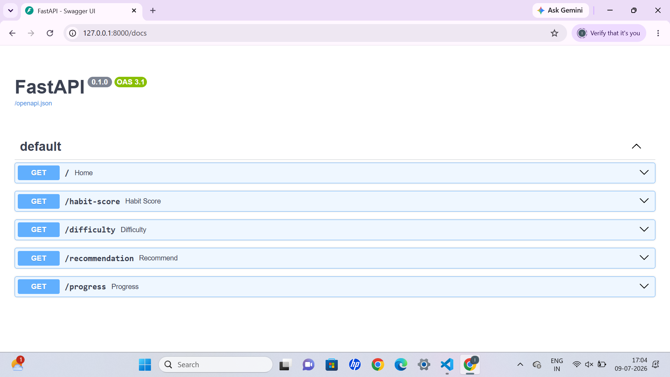

Description: Displays the REST API endpoints available for testing through the Swagger UI.
Figure 4.3: Habit Score API Output
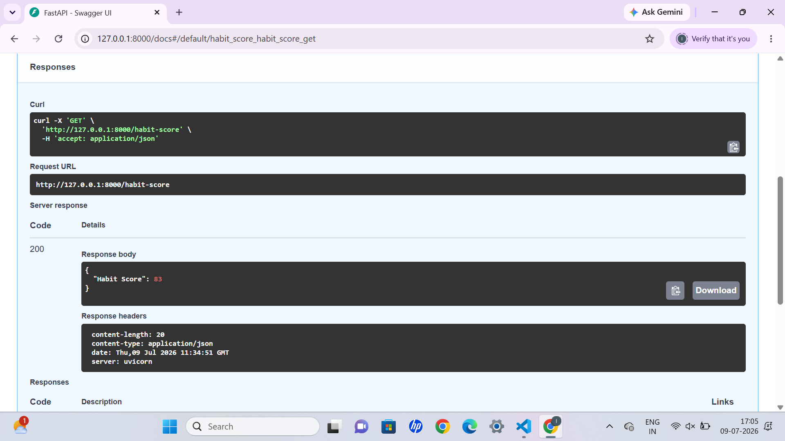Description: Shows the calculated Habit Score generated from the user's wake-up performance
Figure 4.4: Difficulty Prediction API Output
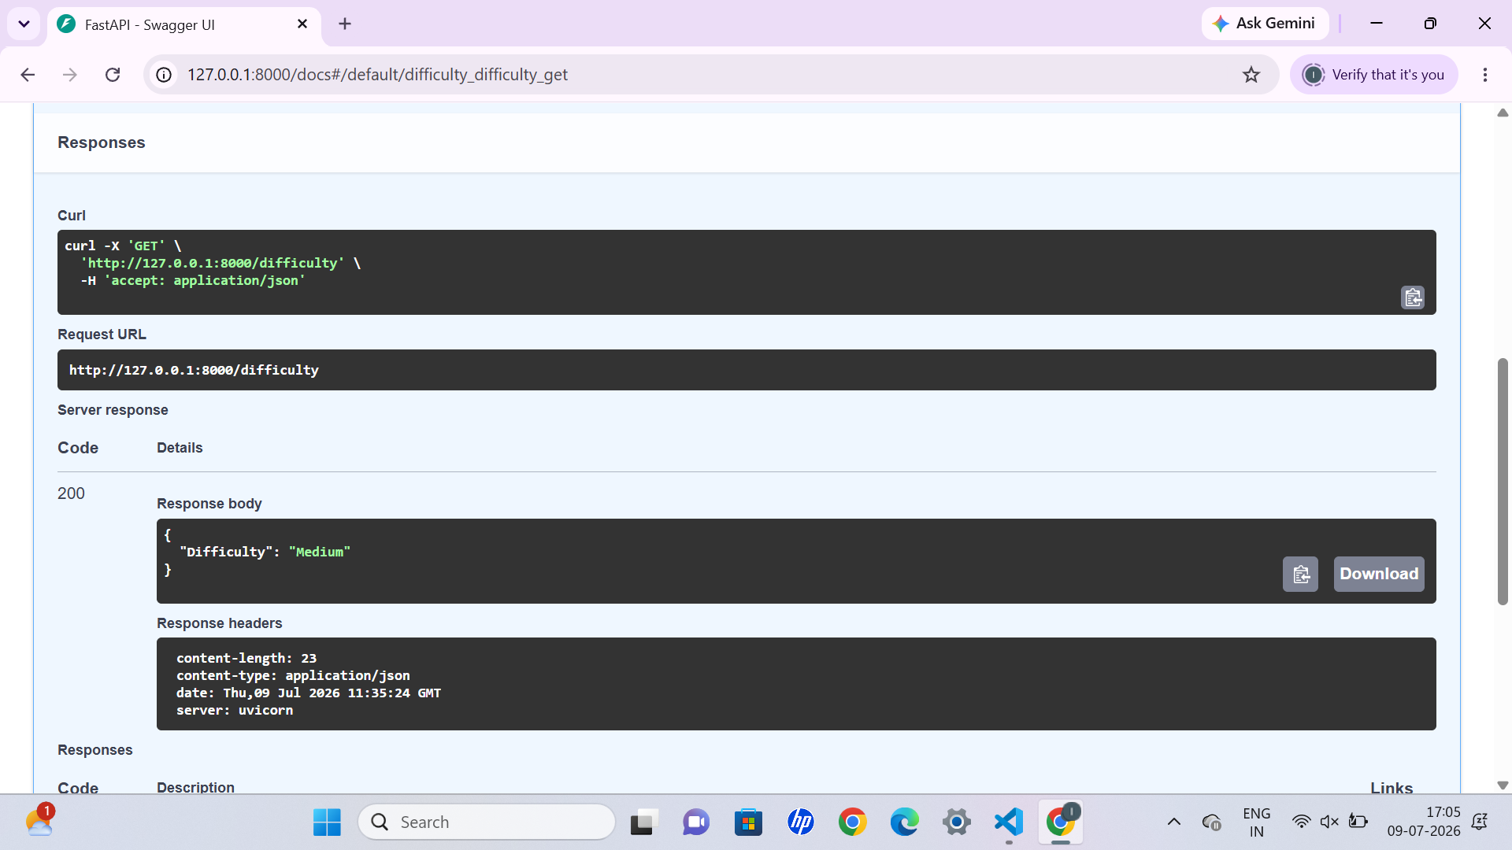
Description: Displays the predicted difficulty level based on the user's Habit Score.

Figure 4.5: Recommendation API Output
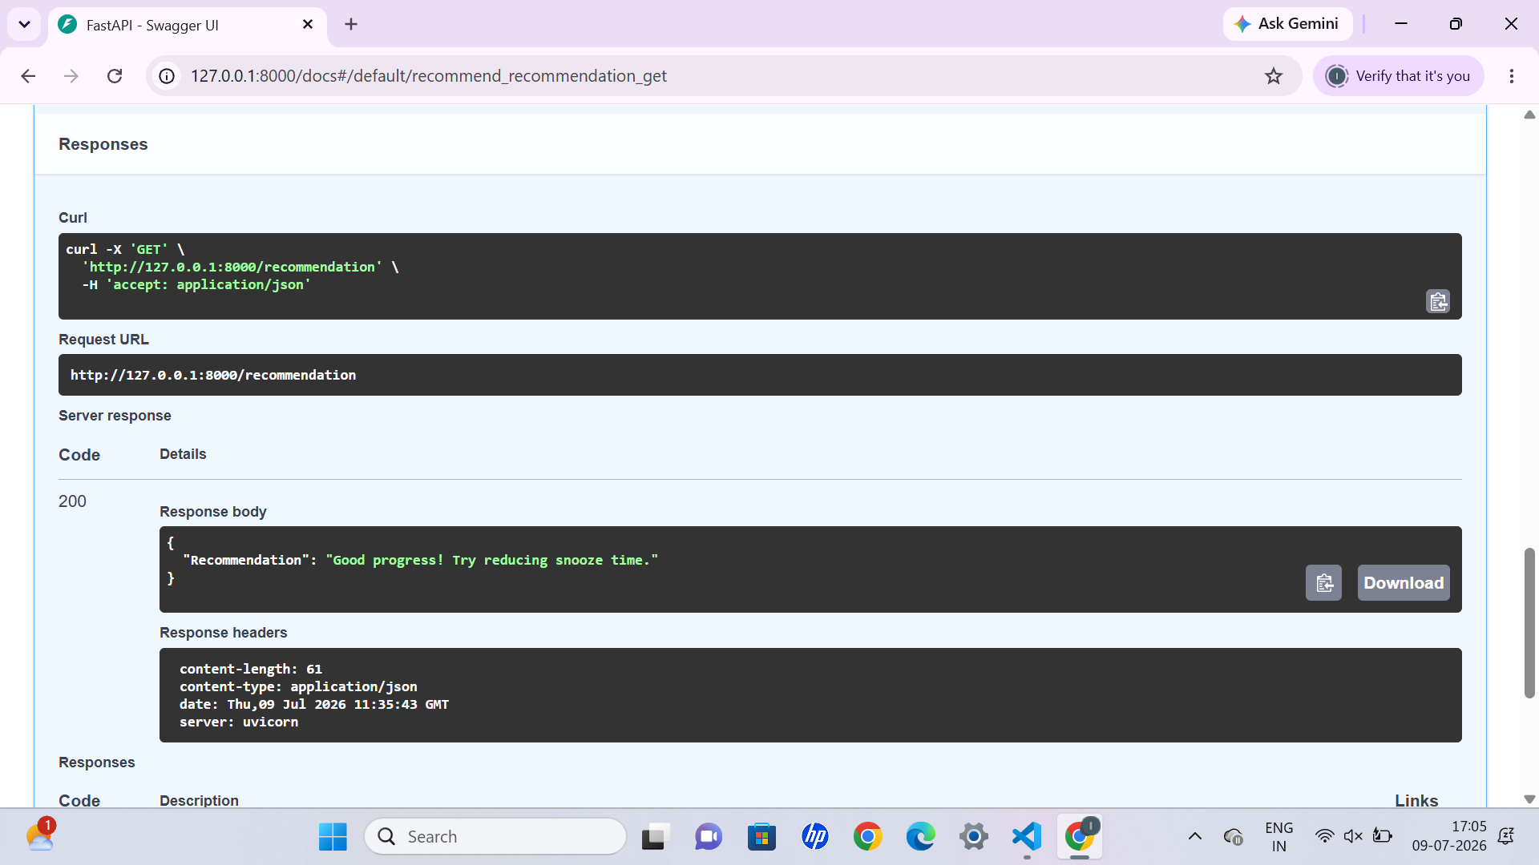Description: Shows the personalized recommendation generated according to the user's habit performance.

Figure 4.6: Progress Tracking API

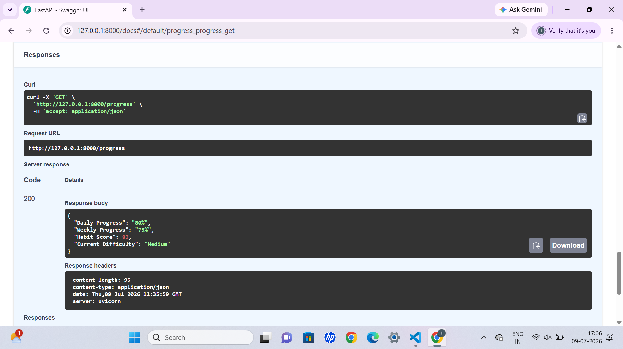

Description: Displays the user's daily and weekly progress along with the current Habit Score and difficulty level.

Conclusion
The Intelligent Cognitive Alarm Platform successfully demonstrates a rule-based AI & Analytics module that calculates Habit Score, predicts difficulty level, provides personalized recommendations, and tracks user progress. The backend was developed using Python and FastAPI, with all APIs successfully tested through Swagger UI. This implementation provides a strong foundation for future machine learning models that will use real user data to generate adaptive recommendations and intelligent alarm behavior.

